

St. Francis de Sales College (Autonomous)
V- Semester BCA Mini Project Report

Submitted by

MANOJ ALVIN V
U03ZW24S0026
BCA III Year 5TH SEM

Under the Guidance of

MAHALAKSHMI S

Department of Computer Science and Applications

2026

ST FRANCIS DE SALES COLLEGE
24, NH 44, VEER SANDRA, HEBBAGODI, BENGALURU, KARNATAKA 560100


PAWTOPIA – PET PRODUCTS E-COMMERCE WEBSITE

INTRODUCTION
Pawtopia is a frontend e-commerce application for browsing pet products and completing a simulated shopping journey. The website brings products for dogs and cats together in one place, with categories for food, treats, toys, grooming, beds, and accessories.
The application is built with React and JavaScript. Reusable components organize the navigation, product cards, category cards, cart items, footer, and notifications. React Router provides navigation between the main pages without full page reloads.
Local mock data supplies product names, descriptions, prices, ratings, brands, categories, sizes, and images. Browser localStorage keeps cart, wishlist, account, and order information available after a page refresh. Login and payment are simulated for demonstration; the project does not connect to a backend or payment provider.
The interface uses a responsive layout intended for desktop, tablet, and mobile screens. The project runs locally with Vite and can be started with the development command described in package.json.

OBJECTIVES
The main objectives of the Pawtopia project are:
To develop a responsive pet-products shopping website using React.
To present dog and cat products in clear categories and product listings.
To show product images, descriptions, brands, ratings, prices, and available sizes.
To provide product search, category and pet filters, price limits, brand and rating filters, and sorting.
To support product detail pages with descriptions, product information, reviews, and related products.
To let users add products to a cart, update quantities, remove items, and view calculated totals.
To provide a wishlist and preserve shopping data in browser localStorage.
To demonstrate login and signup screens using simulated frontend account state.
To guide users through delivery details, a demo payment choice, and an order confirmation.
To organize the application into reusable components, pages, context providers, and product data.

TECHNIQUES USED
Component-Based Development = React components divide the interface into reusable sections.
React State Management = useState() manages changing interface and form values.
React Hooks = useState(), useEffect(), and useMemo() support state, persistence, and derived product lists.
React Router = react-router-dom connects the home, shop, product, account, checkout, and order pages.
Context API = CartContext and AuthContext share cart, wishlist, account, and order data across pages.
Local Storage = pawtopia_cart, pawtopia_wishlist, pawtopia_user, and pawtopia_orders store demo data in the browser.
Responsive Web Design = CSS grid, flex layouts, media queries, and mobile navigation adapt the interface.
Icons and feedback = Lucide React icons and toast notifications communicate actions to the user.

SYSTEM DESIGN

System Architecture
The user opens Pawtopia in a web browser. Vite serves the React application during local development. React Router selects the page for the current URL, while shared context providers make shopping and account state available throughout the site.
Product information is loaded from the local product catalogue. The shop page derives visible products from the search term, selected filters, and sort order. Cart and wishlist actions update React state and are saved to localStorage. Checkout reads the cart state to calculate the order summary, then stores a simulated order in the account context.
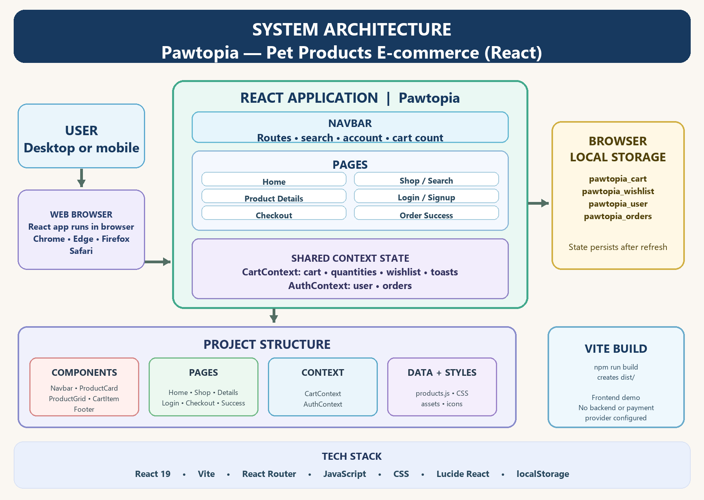
Figure 1. Pawtopia system architecture and local data flow.

IMPLEMENTATION PROCEDURE

Step 1: Project Setup
The application uses Vite for the development server and build process. React, React DOM, React Router, Lucide React, and canvas-confetti are listed in package.json.
src/main.jsx starts the React application.
src/App.jsx provides routing and shared page layout.

Step 2: Home Page
The home page introduces Pawtopia and provides entry points into the catalogue.
Announcement bar and responsive navbar
Hero section with shopping actions
Clickable product categories
Featured and best-selling product cards
Promotional content and footer

Step 3: Product Catalogue
The shop page displays the local product data in a responsive grid. Search terms are passed through the URL, and the page can filter products by category, pet type, brand, rating, and maximum price. Users can sort the results by price, rating, or the available newest option.
Product cards link to product details.
Add to Cart updates the shared cart state.
Wishlist buttons save or remove products.
Mobile filters open in a collapsible panel.

Step 4: Product Details
The product page uses the selected product identifier to display its details, images, price, sizes, description, highlights, and customer review information. The page also provides quantity, wishlist, cart, and related-product actions.

Step 5: Cart and Checkout
Cart items are identified by product and selected size. Adding an existing item increases its quantity. Users can adjust quantities or remove items. The checkout page displays subtotal, savings, delivery fee, and total before collecting delivery details.
Cart count reflects the combined item quantities.
Delivery is free when the subtotal reaches the configured threshold.
Payment options are demonstration choices and do not process transactions.

Step 6: Account and Order Confirmation
Login and signup update simulated account state in the browser. After a valid checkout form submission, the app creates a mock order, clears the cart, and navigates to the order-success page.
Account name is shown in the navigation after login.
Order records are stored in localStorage.
No server-side authentication or order processing is configured.

Step 7: Responsive Navigation
The navbar provides links to the home page, shop, dog and cat listings, search, account, wishlist entry point, and cart. On smaller screens, a menu button reveals the compact navigation and search field.

IMPORTANT FUNCTIONS

Add to Cart
CartContext.addToCart() adds a product and selected size to the cart. If that item already exists, its quantity is increased. A toast confirms the action.

Update Quantity and Remove Items
CartContext.updateQuantity() changes the quantity for a cart item. A quantity of zero removes the item. CartContext.removeFromCart() removes a selected item directly.

Wishlist
CartContext.toggleWishlist() adds a product to or removes it from the wishlist. Wishlist contents are saved in pawtopia_wishlist.

Cart Totals
The cart context calculates the item count, subtotal, original total, and savings from the current cart contents. Checkout adds the applicable delivery fee to calculate the total.

Search and Filters
Navbar search suggestions use product name, category, and brand. Search submission opens the shop with a query parameter. Shop derives matching products from the query and selected filters before applying sorting.

Persistent Demo State
Cart, wishlist, user, and order state are read from and written to localStorage. This provides browser-level persistence and is not a replacement for server storage.

RESULTS AND OUTPUT
The completed Pawtopia application provides a connected frontend shopping flow. Users can browse categories, search and filter products, review product details, manage a cart and wishlist, and complete a simulated checkout. The application presents an order confirmation after checkout.

Home Page
The home page introduces the store, highlights categories, and displays selected products.

Shop Page
The shop page presents the product catalogue with search, filters, sorting, and responsive product cards.

Product Details
The details page provides product information and shopping actions for the selected item.

Cart and Checkout
The checkout page lists selected items and calculates subtotal, delivery fee, savings, and total.

Order Success
After the demonstration checkout is submitted, an order confirmation displays the generated order details.

GitHub Procedure
We used Git and GitHub to save the project source code online and GitHub Pages to deploy the completed website.

Create GitHub Repository
  - Open GitHub.
  - Log in to your GitHub account.
  - Click New Repository.
  - Enter the project name, for example:

smarty-bookstore
  - Select Public.

Click Create Repository. Open Project in VS Code
Open the SMARTY BOOKS project folder in VS Code.

Open Terminal
In VS Code:
Terminal → New Terminal

Step 1: Check Git Installation
First, we checked whether Git was installed. git --version
It displayed the installed Git version

Step 2: Open the Project Folder
We opened the Smarty Books project folder in the terminal.
cd "C:\Users\vasuk\OneDrive\Desktop\Smarty Books\smarty-bookstore" This moved the terminal to the React project directory.

Step 3: Initialize Git
We initialized Git inside the project. git init
This created a Git repository for the project.

Step 4: Check Project Files

We checked the files that Git detected. git status
This showed the project files that were not yet added to Git

Step 5: Add Project Files
All project files were added to Git using:
git add .
The . means all files and folders in the current project are added.

Step 6: Create the First Commit
We created the first version of the project using:
git commit -m "Initial commit - Smarty Books" This saved the current project version in Git.

Step 7: Create GitHub Repository
We created a new repository on GitHub with the project name:
smarty-bookstore
The GitHub repository was used to store the project online.

Step 8: Connect Local Project to GitHub
The local Git repository was connected to the GitHub repository using the GitHub repository URL.
The remote repository was added using:
git remote add origin <GitHub-Repository-URL> We can check the connection using:
git remote -v

Step 9: Push Project to GitHub
The project was uploaded to GitHub using:
git push -u origin master
This uploaded the project files from the computer to the GitHub repository.

GitHub Pages Deployment Procedure
After uploading the project to GitHub, we deployed the website using GitHub Pages. Step 10: Install GitHub Pages Package

We installed the gh-pages package:
npm install --save-dev gh-pages
This package helps publish the React production build to GitHub Pages.

Step 11: Configure Vite
We modified vite.config.js and added the GitHub repository path: base: "/smarty-bookstore/",
This is required so that the React application loads correctly from the GitHub Pages project URL.

Step 12: Add Deployment Commands
In package.json, we added:
"predeploy": "npm run build", "deploy": "gh-pages -d dist"
The build command creates the production version of the React application. The deploy command uploads the production files to GitHub Pages.

Step 13: Create Production Build
We tested the production build using:
npm run build This created the:
dist/
folder containing the optimized production version of the website.

Step 14: Deploy to GitHub Pages
We deployed the project using:
npm run deploy

Step 15: Access the Website
After deployment, the website became available through the GitHub Pages URL: https://<username>.github.io/smarty-bookstore/
The website can be opened from a browser without running: npm run dev
on our computer.

Step 16: Updating the Website
Whenever we make changes to the project, we can update GitHub using: git add .
git commit -m "Update project" git push
Then update the live GitHub Pages website using: npm run deploy
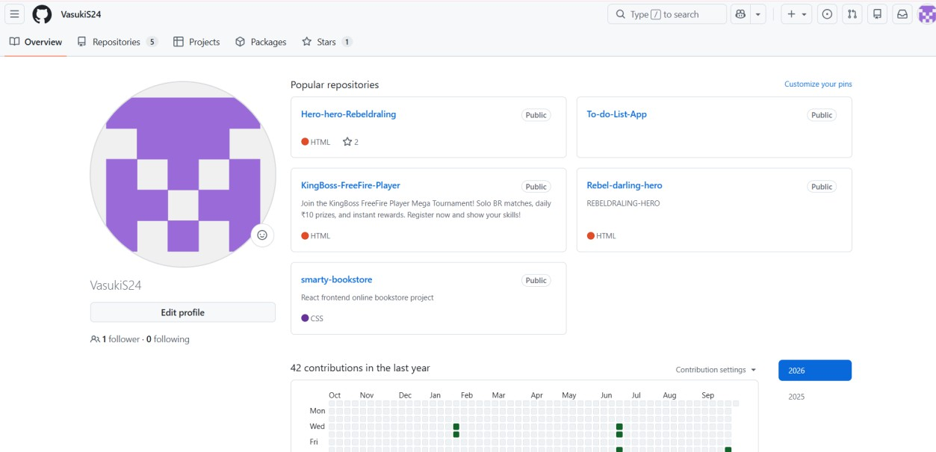

Verify
Open the GitHub repository in the browser. The project files should now be visible online.
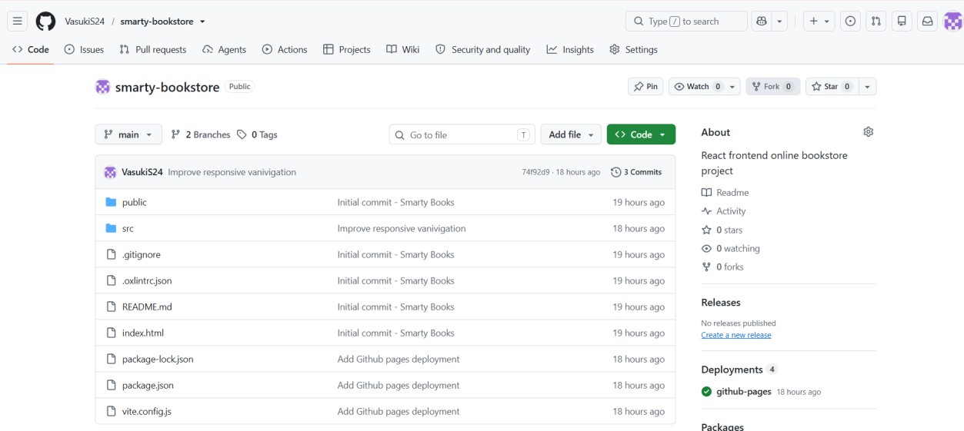

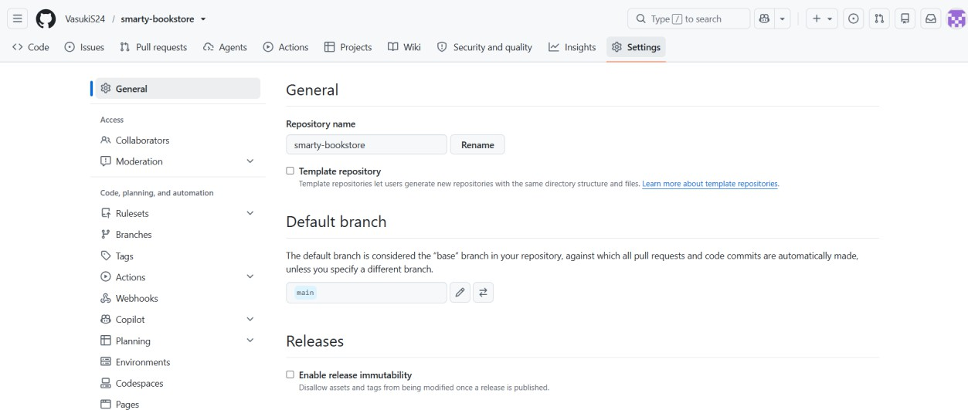
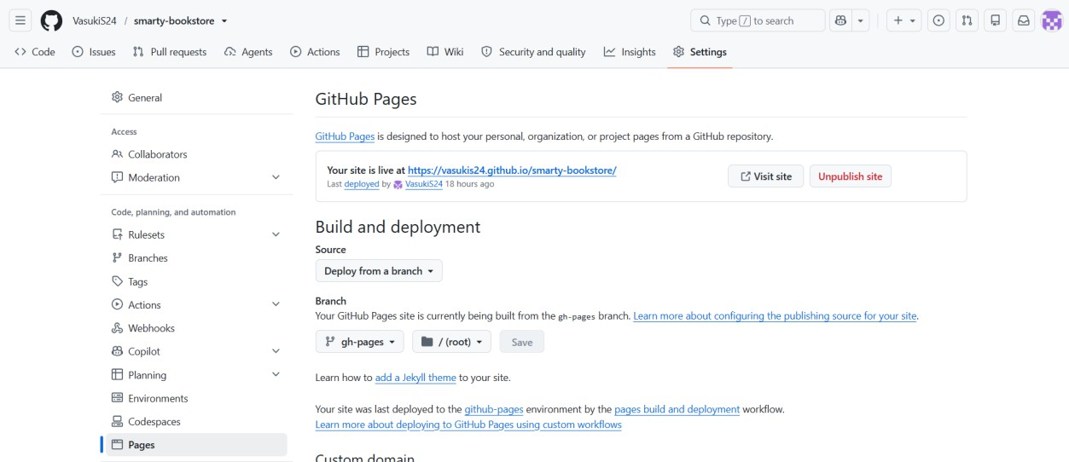

FINAL GITHUB URL
https://vasukis24.github.io/smarty-bookstore/

RESULT ANALYSIS
The Smarty Books – Online Book Store project was successfully developed using React.js, JavaScript, HTML, and CSS. The completed application was tested on both desktop and mobile screen sizes, and the major functions were found to work as expected.

Home Page:
The Home page was successfully created with a hero section, featured books, categories, and navigation options.

Books Page:
The Books page successfully displays available books with title, author, price, category, rating, and image.

Book Details:
Users can select a book and view its detailed information before adding it to the cart or wishlist.

Shopping Cart:
Users can add books to the cart and increase or decrease the quantity as required.

Wishlist:
Users can save their favorite books to the wishlist and remove them whenever needed.

Local Storage:
Wishlist data is stored using browser localStorage, so it remains available after refreshing the page.

Checkout:
Users can proceed from the cart to the checkout page and complete the demonstration order process.

Order Success:
After checkout, an Order Success page is displayed to confirm the completion of the order.

Responsive Design:
The website works properly on desktop and mobile screens with a responsive layout.

Mobile Navigation:
A hamburger menu was implemented for mobile devices to provide easy access to all important pages.

React Navigation:
React Router was successfully used to navigate between Home, Books, Details, Cart, Wishlist, Checkout, and other pages.

GitHub Deployment:
The completed project was uploaded to GitHub and successfully deployed using GitHub Pages for online access.

CONCLUSION
The Smarty Books – Online Book Store project was successfully designed and developed as a modern, responsive web application using React.js, JavaScript, HTML, and CSS. The main aim of the project was to create a simple and user-friendly online platform where users can browse books and perform basic shopping activities through a web browser.
The application successfully provides important features such as Home page, Books listing, Book Details, Shopping Cart, Wishlist, Checkout, and Order Success. Users can add books to the cart, change quantities, save favorite books to the wishlist, and proceed through the checkout process.
React Router was used to provide smooth navigation between different pages, while React state management was used to handle dynamic features such as cart and wishlist operations. The wishlist was also stored using browser localStorage, allowing the saved books to remain available after refreshing the webpage.
The application was designed with responsive web design, making it suitable for both desktop and mobile devices. A separate hamburger navigation menu was implemented for mobile users to provide easy access to the main sections of the website.
The project also provided practical experience with Git and GitHub for version control and source-code management. After completing development and testing, the application was successfully built and deployed using GitHub Pages, making the website accessible through the Internet without running the development server.
Overall, the Smarty Books project successfully demonstrates the practical application of modern frontend development concepts.

